Mackie Control Surfaces Support
for Cakewalk by BandLab
Updated: 16-July-2019

2019-07 Enhancements
The following new options are now available on the Mackie Control property page:

Original MackieControl Surface Property Page | 2019-07 Enhancements
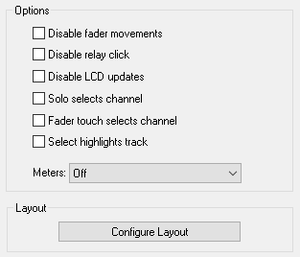 | 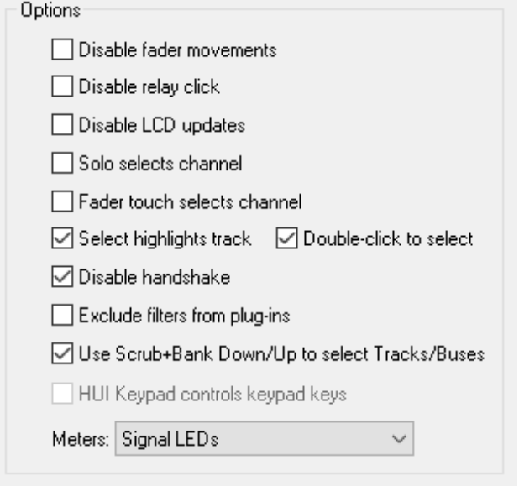  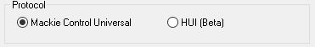

Protocol
You can now select between the Mackie Control Universal protocol (the default protocol), or the HUI protocol (beta), which was originally designed for the Mackie HUI device for ProTools. If your device does not support the MCU protocol but supports the HUI protocol, you can choose this option.

If your device supports both the MCU & HUI protocols, it is recommended that you choose MCU.

Double-click to select
This option is aimed at users of the Korg nanoKONTROL Studio control surface, and is used in conjunction with the “Select highlights track” option.

Although the nanoKONTROL Studio’s track select buttons operate properly when the “Select highlights track” option is checked, the highlighted track is also changed every time a fader is moved. This is because the Korg nanoKONTROL Studio sends a “select track” message not only when a track select button is pressed, but also when a track’s fader is moved.

When “Double-click to select” is checked, fader movements no longer change the highlighted track, however the user can press the select button twice (i.e. double click it) to change the highlighted track.

Disable Handshake
This option disables the initial handshake with the hardware control surface when Cakewalk by BandLab loads the control surface.

Earlier versions of the MCU protocol required a handshake in order for Cakewalk by BandLab to start communicating. Later versions of the MCU protocol no longer have this requirement, and therefore many control surfaces that support the MCU protocol do not support the handshake feature.

If your control surface does not have a specific mode to support SONAR or Cakewalk by BandLab, select this option.

This option is always enabled when using the HUI protocol.

*Originally developed by Azslow3

Exclude filters from plug-ins*
By default, support is enabled for the ProChannel EQ, Track Compressor and Bus Compressor, when using the EQ or Dynamics buttons on the MCU or C4.

Checking this option disables this support.

*Originally developed by Azslow3

Use Scrub+Bank Down/Up to select Tracks/Buses
This option is aimed at users of the Korg nanoKONTROL Studio.

The Korg nanoKONTROL Studio has no buttons to switch between controlling Tracks and Buses, and is set to control Tracks by default.

Enabling this option gives the following behaviour:

Scene button + Bank Down button : Control Tracks
Scene button + Bank Up button : Control Buses

NOTE: For this to work, the Korg nanoKONTROL Studio must be configured to use the Scene button as the Scrub button, by enabling the “Use Scene Button as Scrub” Global Parameter, using the KORG KONTROL Editor software.

Automatic Fader Offset Assignment
If you have more than one Mackie Control device (e.g. Mackie XT + Mackie MCU + Mackie C4), the Mackie Control will now automatically assign the fader offsets for XT and MCU units based on the order you add them within Cakewalk’s Control Surfaces preferences.

This is useful for control surfaces that do not have vpots, or for control surfaces that do not have a display making it difficult to use the “Configure Layout” mode.

If your XT unit(s) are to the left of your MCU, make sure you add your XT surfaces first, e.g:

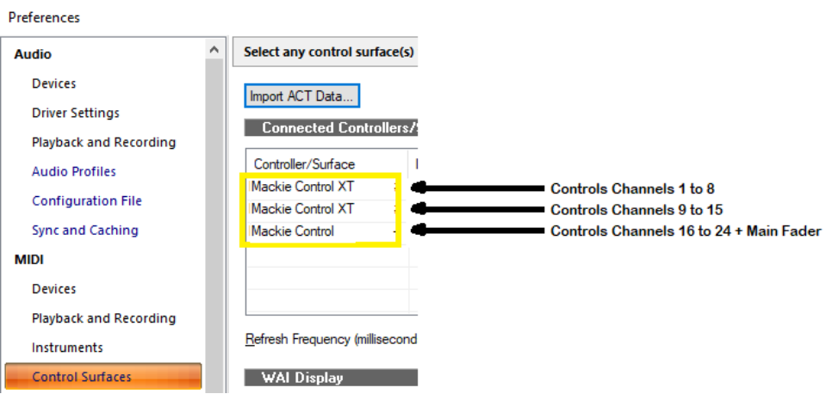

If your XT unit(s) are to the right of your MCU, make sure you add your MCU first e.g.:
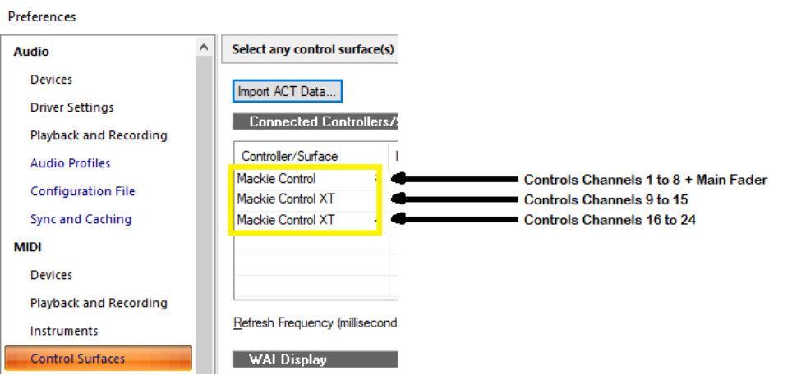

The fader offset assignment is made at the time you add your controllers within Cakewalk’s Control Surfaces preferences, so you can override the automatic fader offset assignment by using the “Configure Layout” button.

If your controller does not have a display or vpots, and you wish to change fader offset assignment, it may be easier to remove all the controllers from the list within Cakewalk by BandLab’s Control Surfaces preferences and add them in the desired order.

The automatic fader offset does not affect the Mackie C4, and its order within the Control Surfaces Preferences.

HUI Keypad controls keypad keys
When checked, the HUI numerical keypad will simulate the keypad of your PC keyboard.
When unchecked, the HUI numerical keypad will simulate the standard numerical keys (i.e. the ones above the QWERTY keys).
This option is aimed at users of the Mackie Human Interface Controller (HUI), and is only available when the HUI protocol is selected.

Key Press support

In addition to the standard list of commands, the MCU function buttons and foot switches can now be configured to send a key press to Cakewalk by BandLab:
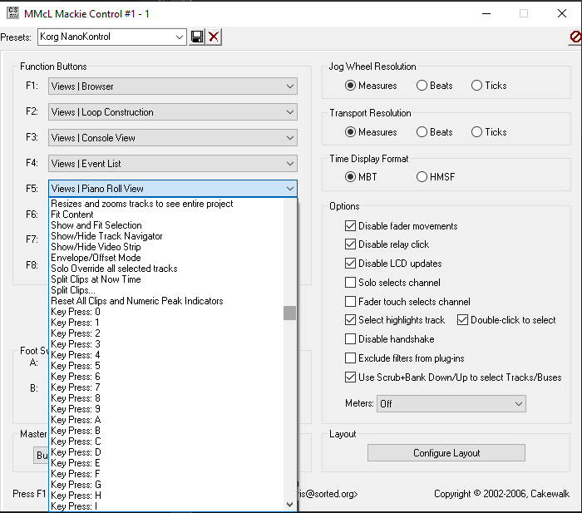

When used in conjunction with the Keyboard Shortcuts settings within Cakewalk by BandLab, this can greatly enhance the functionality of the function buttons over the standard list of commands, e.g. by configuring an MCU function button to run a CAL script.

Additional Button Mapping:

F1/CUT, F2/COPY and F3/PASTE buttons now have extra modifier behaviour (in red below):

 |  | M1 | M2 | M3 (beta) | M4
F1/CUT | F1 | Cut | Cut Special |  | Reload  Plugin  Mappings
F2/COPY | F2 | Copy | Copy Special | Export track template & save as  __mcu-temp-track-template__.cwx | Copy Special & press OK
F3/PASTE | F3 | Paste | Paste Special | Imports template  __mcu-temp-track-template__.cwx | Paste Special  & press OK

WARNING: Saving / Importing the track templates using the M3 modifier will clear the current clipboard.

Additional modifiers can now be used with the Save and Tracks buttons:

 |  | M1 | M2 | M3 | M4
Save | Save | Save As | Save Copy As | Export Audio
Track | Control  Tracks | Export  Track  Template | Import  Track  Template | Bounce to Tracks | Bounce to Clip(s)

The following behaviour was added for the Korg NanoKONTROL 2:

Cycle + Rewind | Go to Start
Cycle + Record | Undo
Cycle + Marker Navigation Right | Insert Marker
Cycle + Track Down | Control Tracks
Cycle + Track Up | Control Buses

Fader Reset on Close
Motorised faders now return to zero on close of project or when closing Cakewalk.

HUI Support (Beta)

The MackieControl now supports the HUI protocol for use with the Mackie Human Interface Controller (HUI), or devices that only support HUI and not MCU.

HUI support is currently beta. Although many functions have been implemented, there are many that have not.

The following buttons/functions should work:
- Channel V-Pot (pan), Arm, Solo, Mute, Select, Faders
- Fader Meters (set Meters to “Signal Leds”)
- The four character channel scribble strip display for track names
- The time code display, and the buttons controlling the time code modes (SMPTE / BEATS)
- Jog Wheel, Scrub button, Zoom button and cursor buttons
- Transport Buttons
- Loop On/Off
- The HUI numeric keypad
- The Channel Up/Down buttons
- The Bank Up/Down buttons
- The Save button
- The button LEDs for all of the above

The following features are NOT supported at present:
- Controlling plugins
- The V-Pots and 40x2 LCD displayed
- Devices with more than 8 channel fader strips
- Switching between buses & tracks

Editing MackieControl.ini

Note: The following section was taken from an archive of an article written by Chris Boucher (the original developer of the MackieControl.dll). The original article can be found here:
https://web.archive.org/web/20120625023520/http://www.chrisboucher.com/cakewalk/mackiecontrol/
The MackieControl.ini file defines how plugin parameters are mapped across the VPots of the control surface. If a plugin is not listed in the file, its parameters are simply mapped in the order the plugin presents them to Cakewalk. By adding a plugin to the ini file, the parameters can be remapped into a consistent order.
In addition to rearranging the parameters, the ini file also allows the data type/display format (for the Halo of LEDs around each VPot) and default values to be defined for each parameter. A plugin can also be identified as an Equaliser or Dynamics processor for quick access via the EQ and DYN buttons on the control surface.
Finally, for Equaliser plugins, the special frequency/gain mode where the faders control level and the VPots control frequency, can be defined.

How To Add a Plugin
Let's say we want to add a new (fictitious) plugin called EqX, a simple two band equaliser. Firstly, add the plugin to a Cakewalk track and press PLUG-INS twice, to enter SINGLE CHANNEL mode where the plugin parameters are mapped across the VPots.
Using the BANK and CHANNEL buttons (in EDIT mode), we find that there are 9 parameters available:
Parameter Number | Parameter Name
0 | Bypass
1 | Band 1 Enable
2 | Band 1 Gain
3 | Band 1 Frequency
4 | Band 1 Q
5 | Band 2 Enable
6 | Band 2 Gain
7 | Band 2 Frequency
8 | Band 2 Q
Note that the parameters are numbered starting at zero.
The MackieControl.ini file is located in the "Cakewalk\Shared Surfaces" directory, in my default install this is "C:\Program Files\Cakewalk\Shared Surfaces". It's a simple text file, so you can edit it using it using notepad.
Before going any further, take a backup of this file, just to be safe

The first section at the top of the file lists the plugins defined in the file, and looks something like:
[Plugins]
0=FxChorus
1=FxDelay
2=FxEq
3=FxFlange
4=FxReverb
5=CompressorX (Sonar XL)
6=Equalizer (Sonar XL)
7=Track Eq
8=Bus Eq
9=ProChannel EQ
10=Track Compressor
11=Bus Compressor

The first step is to add a new entry for our plugin, so we add the line:
12=EqX
to the end of the[Plugins]section.
Note: the name of the plugin must exactly match the name as shown in Cakewalk and on the desk (if you press PANS and then PLUG-INS the name will be displayed for a couple of seconds).
Now we need to add a new section, defining how the parameters are to be mapped. Add the line:
[EqX]
to the end of the file.
To start with, we're just going to reorder the parameters. We'll be using 9 VPots (since there are 9 parameters), so add the line:
NumVPots=9
And now we'll add the parameters themselves, but change their order:
[EqX]
NumVPots=9
VPot0=3 ; Band 1 Frequency
VPot1=7 ; Band 2 Frequency
VPot2=4 ; Band 1 Q
VPot3=8 ; Band 2 Q
VPot4=2 ; Band 1 Gain
VPot5=6 ; Band 2 Gain
VPot6=1 ; Band 1 Enable
VPot7=5 ; Band 2 Enable
VPot8=0 ; Bypass
Everything after the ; is simply a comment. Like parameters, the VPots are numbered starting at zero.
So now VPot0 (the first VPot) is set to control parameter 3, which in this case is Band 1 Frequency.
Pressing M4-F1 on the Mackie causes the control surface module to reload the ini file and rebind the VPots - very useful for checking that everything is reordered correctly.
We now need to define what type of data each VPot/parameter controls - this information is used to control the Halo of LEDs around the VPots and what happens when a VPot is pressed. The options are: level, pan, freq, switch, boost/cut and spread.
The data type is added after the parameter number, separated by a comma:
[EqX]
NumVPots=9
VPot0=3,freq ; Band 1 Frequency
VPot1=7,freq ; Band 2 Frequency
VPot2=4,spread ; Band 1 Q
VPot3=8,spread ; Band 2 Q
VPot4=2,boost/cut ; Band 1 Gain
VPot5=6,boost/cut ; Band 2 Gain
VPot6=1,switch ; Band 1 Enable
VPot7=5,switch ; Band 2 Enable
VPot8=0,switch ; Bypass
For data types other than switch, a default value can also be defined. This is the value assigned to the parameter when the VPot is pressed. Note: the value must be in the range 0.0 - 1.0:
[EqX]
NumVPots=9
VPot0=3,freq,0.25 ; Band 1 Frequency
VPot1=7,freq,0.6 ; Band 2 Frequency
VPot2=4,spread,0.2 ; Band 1 Q
VPot3=8,spread,0.2 ; Band 2 Q
VPot4=2,boost/cut,0.5 ; Band 1 Gain
VPot5=6,boost/cut,0.5 ; Band 2 Gain
VPot6=1,switch ; Band 1 Enable
VPot7=5,switch ; Band 2 Enable
VPot8=0,switch ; Bypass
The switch data type doesn't have a default value, instead pressing the VPot toggles the parameter on and off.
As you turn a VPot, the parameters are adjusted in steps of 0.05. For some parameters this may be too coarse so, finally, the step size for each parameter may be defined. Here I've reduced the step size for the frequency controls to 0.02:
[EqX]
NumVPots=9
VPot0=3,freq,0.25,0.02 ; Band 1 Frequency
VPot1=7,freq,0.6,0.02 ; Band 2 Frequency
VPot2=4,spread,0.2 ; Band 1 Q
VPot3=8,spread,0.2 ; Band 2 Q
VPot4=2,boost/cut,0.5 ; Band 1 Gain
VPot5=6,boost/cut,0.5 ; Band 2 Gain
VPot6=1,switch ; Band 1 Enable
VPot7=5,switch ; Band 2 Enable
VPot8=0,switch ; Bypass
Before going further, we should also define the type of plugin. There are three options 0 (everything else), 1 (equaliser) and 2 (dynamics). If a plugin is type 1, then it can be accessed by pressing the EQ button. Similarly, type 2 plugins can be accessed via the DYN button.
EqX is an equaliser, so:
[EqX]
PluginType=1
NumVPots=9
VPot0=3,freq,0.25,0.02 ; Band 1 Frequency
VPot1=7,freq,0.6,0.02 ; Band 2 Frequency
VPot2=4,spread,0.2 ; Band 1 Q
VPot3=8,spread,0.2 ; Band 2 Q
VPot4=2,boost/cut,0.5 ; Band 1 Gain
VPot5=6,boost/cut,0.5 ; Band 2 Gain
VPot6=1,switch ; Band 1 Enable
VPot7=5,switch ; Band 2 Enable
VPot8=0,switch ; Bypass
You can also rebind the VPots for each of the four MODIFIERS (M1 - M4). For equalisers the convention I've used so far is that if the unmodified VPot controls frequency, then pressing M2 makes it control the corresponding Q, M3 controls Gain and M4 controls the Enable:
[EqX]
PluginType=1
NumVPots=9
VPot0=3,freq,0.25,0.02 ; Band 1 Frequency
VPot1=7,freq,0.6,0.02 ; Band 2 Frequency
VPot2=4,spread,0.2 ; Band 1 Q
VPot3=8,spread,0.2 ; Band 2 Q
VPot4=2,boost/cut,0.5 ; Band 1 Gain
VPot5=6,boost/cut,0.5 ; Band 2 Gain
VPot6=1,switch ; Band 1 Enable
VPot7=5,switch ; Band 2 Enable
VPot8=0,switch ; Bypass
M2VPot0=4,spread,0.2 ; Band 1 Q
M2VPot1=8,spread,0.2 ; Band 2 Q
M3VPot0=2,boost/cut,0.5 ; Band 1 Gain
M3VPot1=6,boost/cut,0.5 ; Band 2 Gain
M4VPot0=1,switch ; Band 1 Enable
M4VPot1=5,switch ; Band 2 Enable
You can rebind M1 too, but as it's normally used to enter fine adjustment mode, it's generally better if you don't.

C4Mapper Utility
The C4Mapper utility is a graphical editor for MackieControl.ini file:
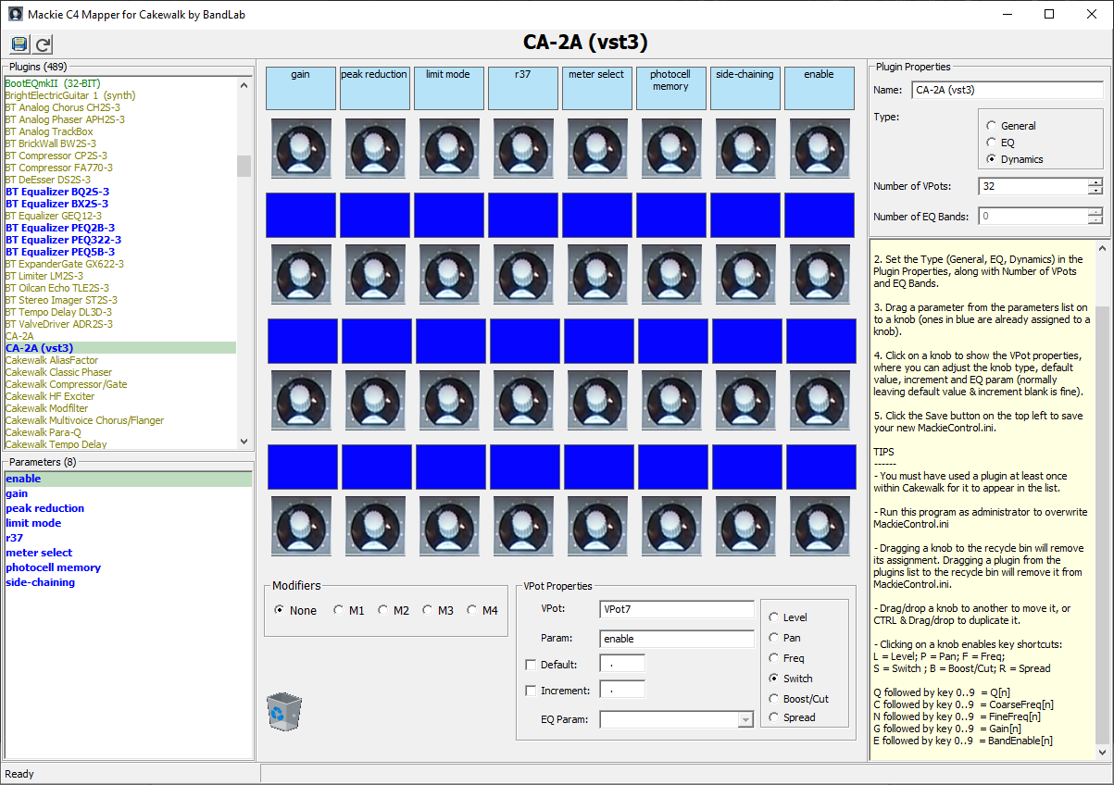
C4Mapper lists all the plugins currently registered with Cakewalk by BandLab, and allows you to assign their parameters to a particular VPot by dragging the parameter from the list of parameters on the left, to the corresponding VPot in the middle of the editor.
Although the C4Mapper is primarily designed for the Mackie C4, by limiting the number of VPots to the top row of 8 VPots, it can be used with the Mackie Control.

